Assignment – 01
- Draw a labeled diagram of a typical home Wi-Fi setup showing a modem, router, switch, access point, and at least two devices (like a laptop and smartphone) connected to the network.

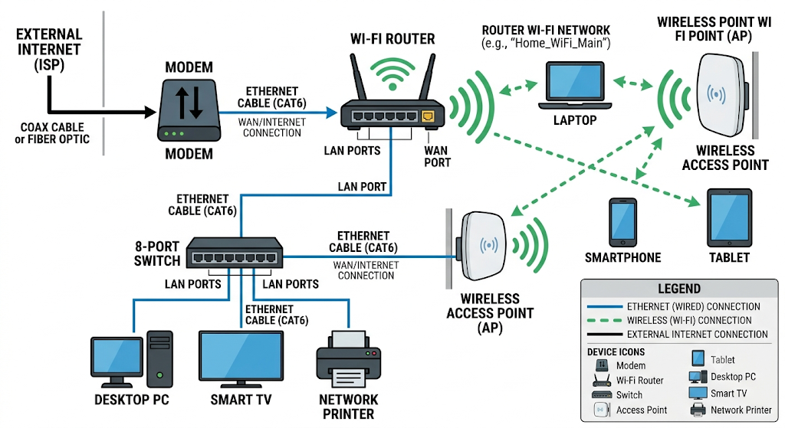

- List the main function of each networking hardware device: modem, router, switch, access point, and network cable. For each, give a real-life example of where you might see or use it (for example, 'router: at home to share internet').

Networking Hardware | Main Function | Real-Life Example
Modem | Connects your network to the Internet service provider (ISP) and converts signals so internet data can be transmitted. | Used at home to receive internet service from an ISP.
Router | Connects different networks and directs internet data to the correct device. | Used at home to share internet with phones, laptops, and TVs.
Switch | Connects multiple devices within the same local network (LAN) and sends data to the correct device. | Used in an office to connect computers, printers, and servers.
Access Point (AP) | Provides wireless (Wi-Fi) access to a wired network. | Used in a college or office to provide Wi-Fi to students/employees.
Network Cable | Provides a wired connection for transmitting data between network devices. | Used to connect a computer to a router or switch using an Ethernet cable.

- Take photos or find images online (with source links) of at least three types of network cables (such as Ethernet, coaxial, fiber optic) and write one line describing where each is commonly used.

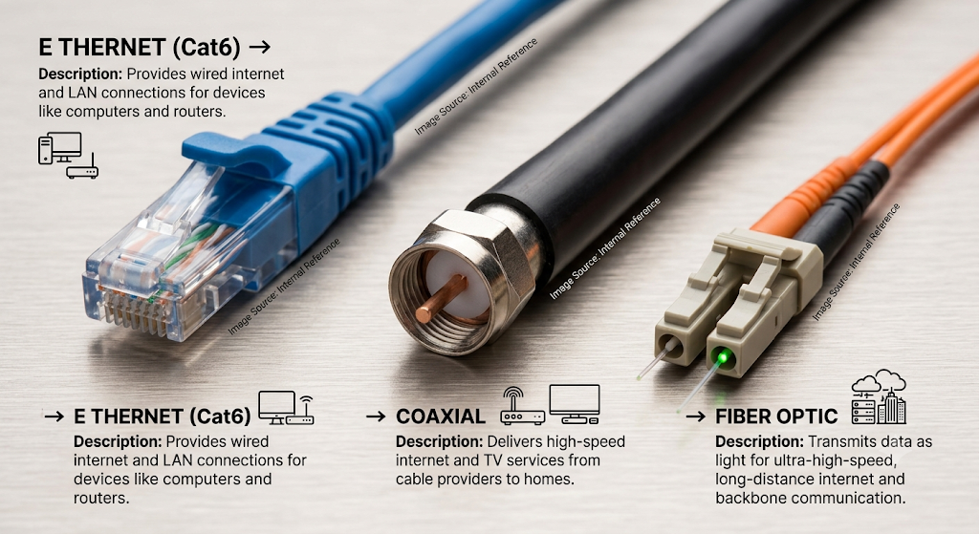

- Create a comparison table listing at least four differences between a router and a switch, including their main use, typical location, and how they handle data.

Difference | Router | Switch
1. Main Use | Connects different networks and shares internet. | Connects multiple devices within the same network.
2. Typical Location | Commonly found at homes and offices, connecting to the modem/ISP. | Commonly found in offices, schools, and data centers.
3. Data Handling | Directs data packets between different networks using IP addresses. | Forwards data between devices using MAC addresses.
4. Internet Connection | Usually provides internet access to connected devices. | Usually does not directly provide internet; it connects devices to a LAN.
5. Example | Home router connects phones, laptops, and TVs to the internet. | Office switch connects computers, printers, and servers together.
6. Network Layer | Mainly operates at Layer 3 (Network Layer). | Mainly operates at Layer 2 (Data Link Layer).

